Music Box with Lid

Base:

Extrusion:

Front/back:

Extrusion:

Sides, hole is for the lid, acts as a part of the latch:

Extrusion:

Transform:

Move and copy of the front/back part:

Move, transform, and cut. Base box is formed

Lid, small amount is uncovered to ensure that the lid can open:

Lid extruded:

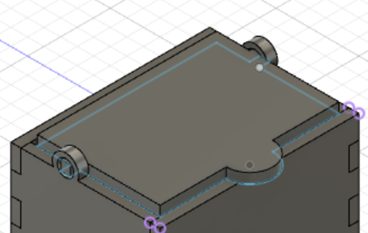

Modification to right side to allow for the hole:

Producing of the sketches:

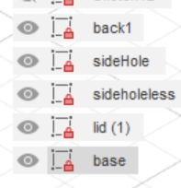

Saving them as Inkscape compatible files (DXF):

Added details to be engraved:

Printed set, 2 pieces wrong:

Modified pieces:

Re-cut pieces:

Final product

